Assignment-6.4
Task-1; • Start a Python class named Student with attributes name, roll_number, and marks. Prompt GitHub Copilot to complete methods for displaying details and checking if marks are above average
Code and output;
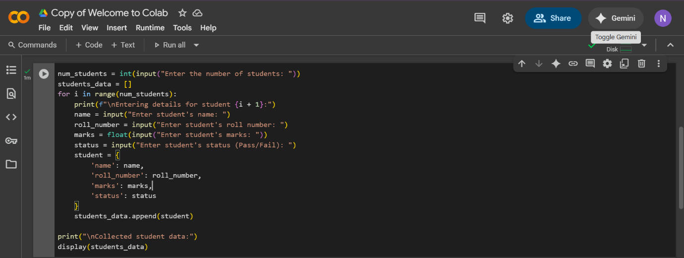
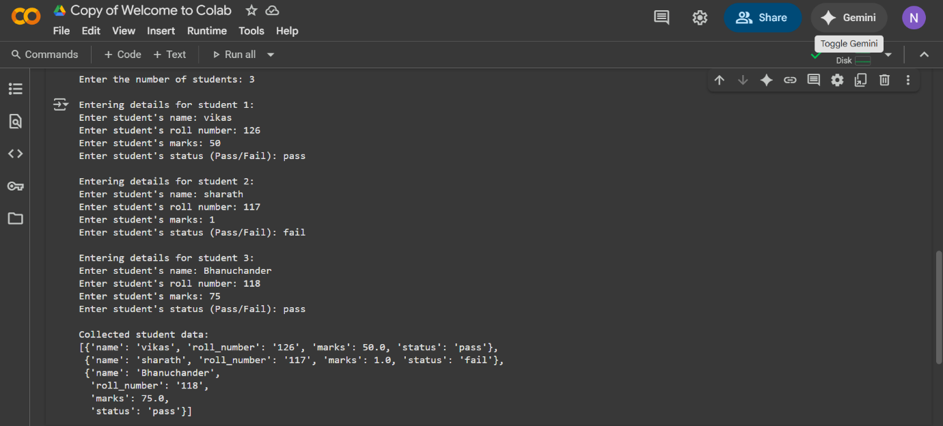
Explanation;
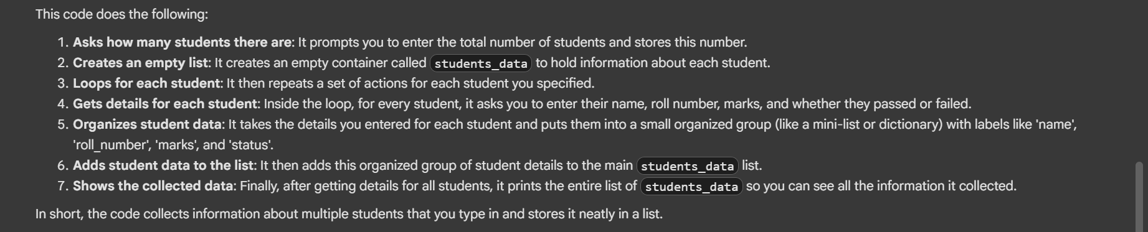
Task-2; • Write the first two lines of a for loop to iterate through a list of numbers. Use a comment prompt to let Copilot suggest how to calculate and print the square of even numbers only.
Code and output;
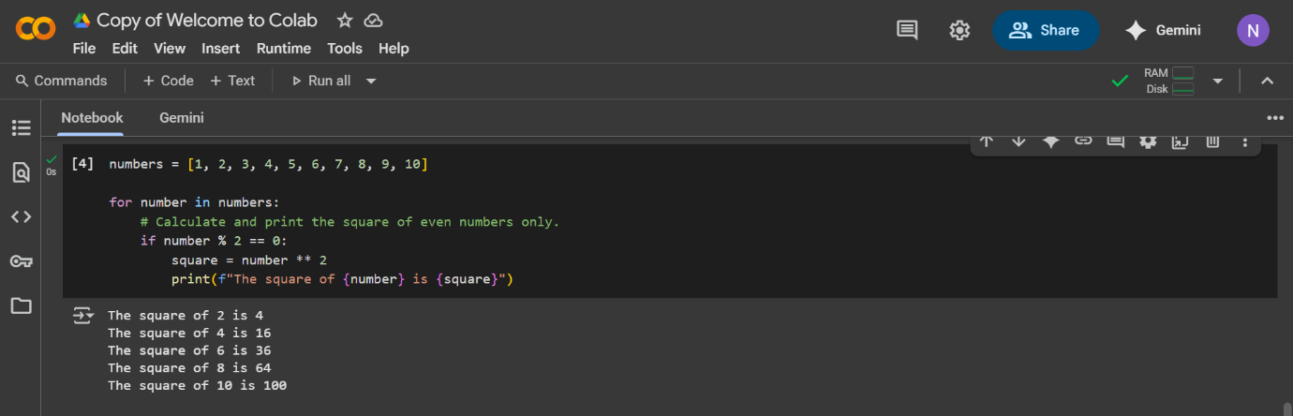
Explanation;
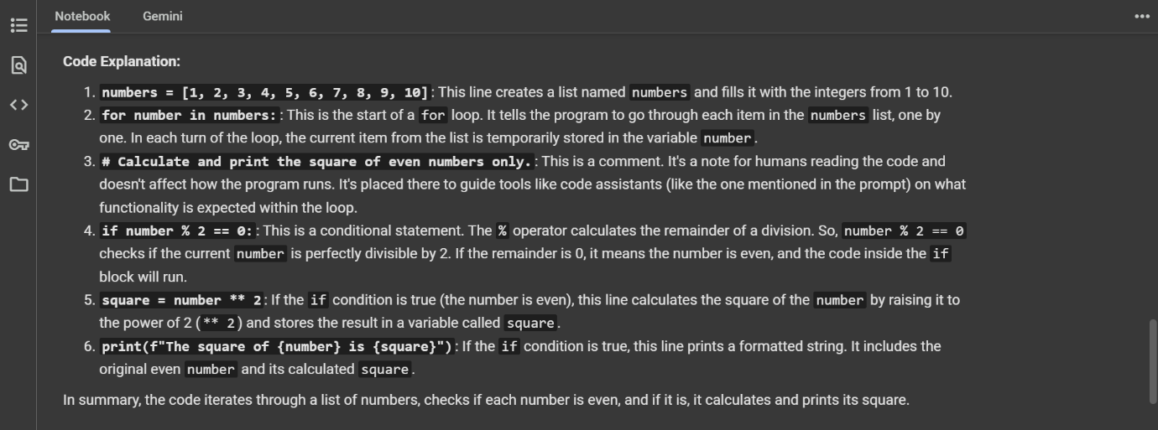

Task-3; Create a class called BankAccount with attributes account_holder and balance. Use Copilot to complete methods for deposit(), withdraw(), and check for insufficient balance.
Code and output;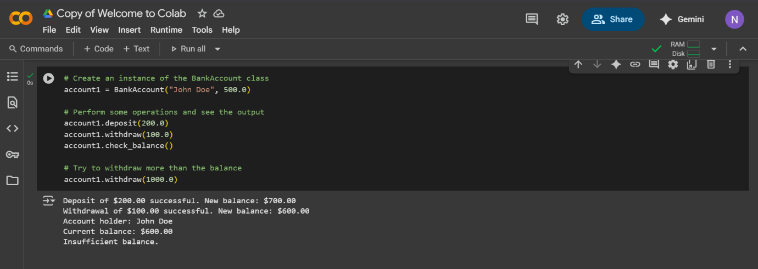
Explanation;
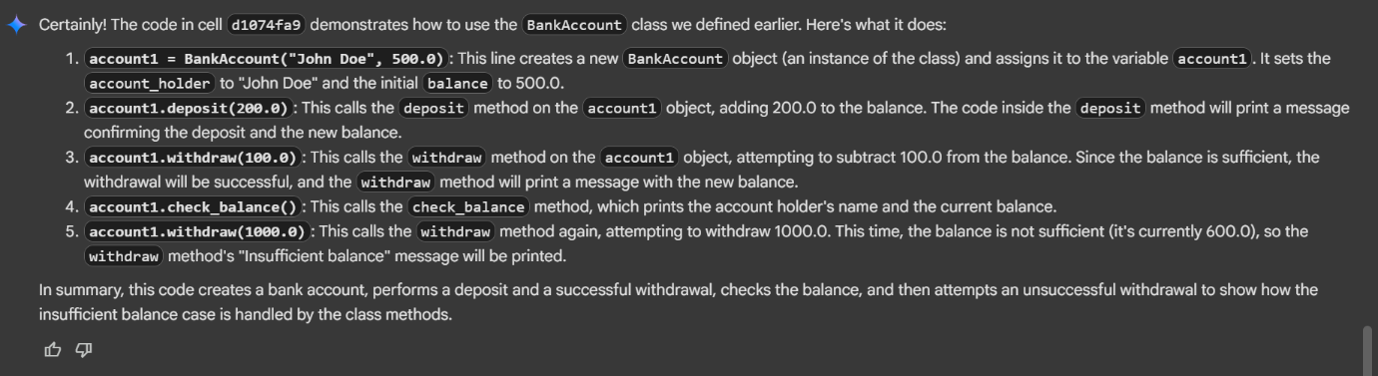

Task-4; Define a list of student dictionaries with keys name and score. Ask Copilot to write a while loop to print the names of students who scored more than 75.
Code and output;
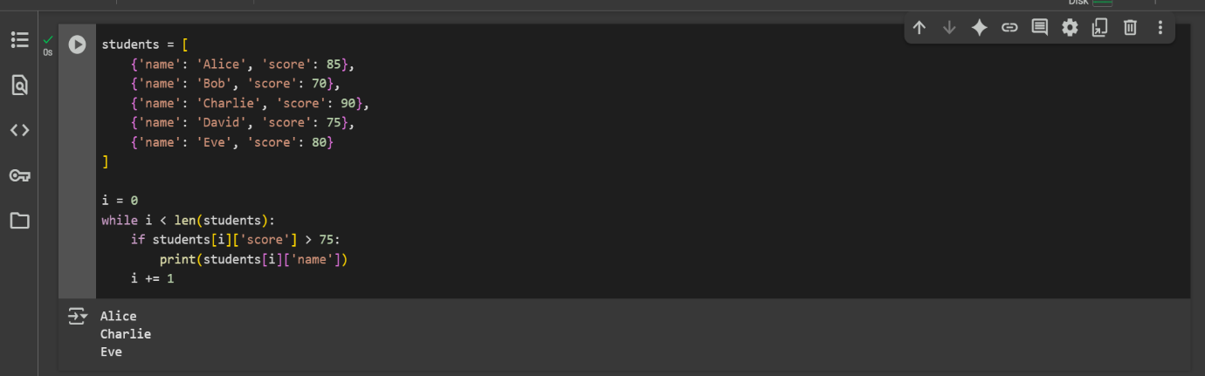

Explanation;
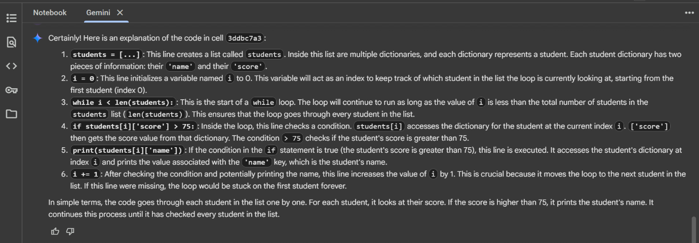

Task-5; • Begin writing a class ShoppingCart with an empty items list. Prompt Copilot to generate methods to add_item, remove_item, and use a loop to calculate the total bill using conditional discounts.
Code and output;
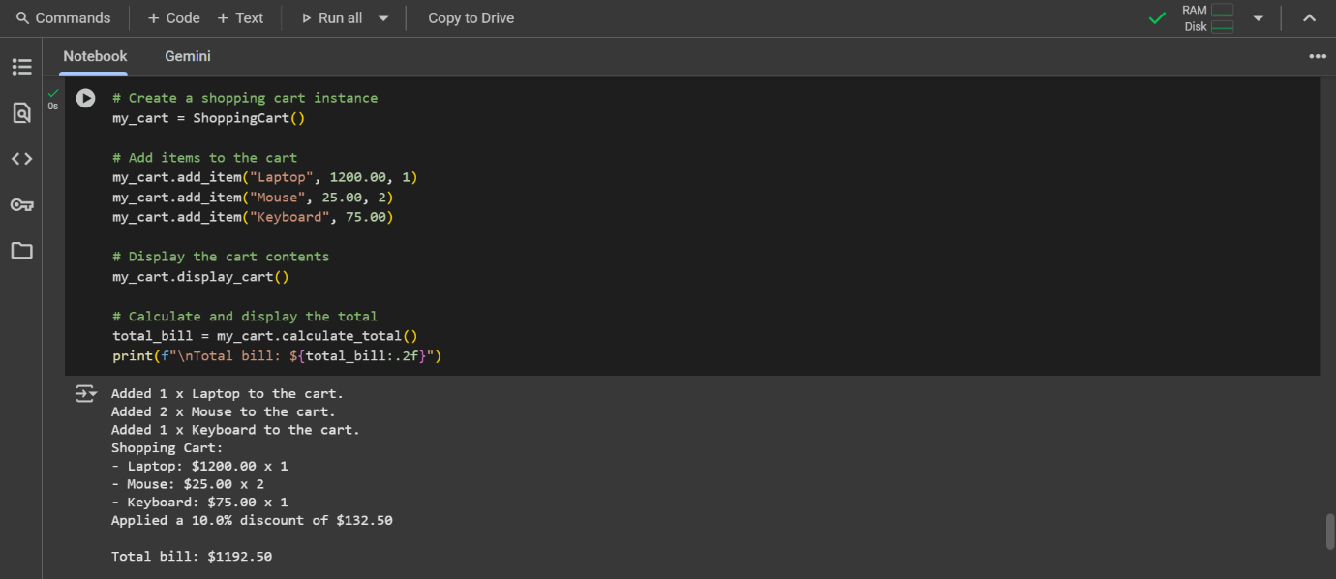

Explanation;
